To fix:

1. Can can only write 6 numbers code, but some clients have only 4 numbers code. So need so be able to write a password between 4 and 6 numbers

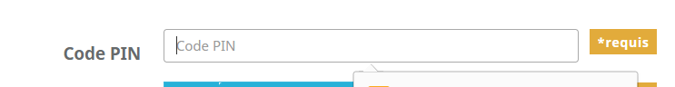

1. If the client has no code, need to create the same option as for iCloud account

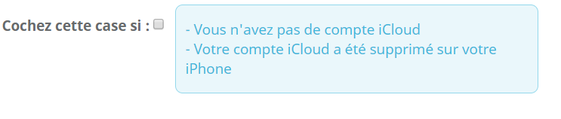

Here is the text to write in the blue box

French “ - Vous n’avez pas de code”

English “ – If you don’t have any code”

1. Need to had one more option for the Phone condition

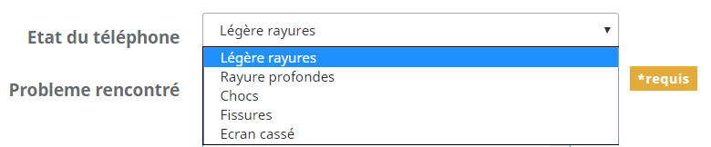

French : “Comme neuf”

English : “As new”

1. I get a server error when I want to validate the ticket

